CAITHNESS & SUTHERLAND WOMEN’S AID
SC-034356
We are a charity giving information, support and advice to women, children and young people who have experience of domestic abuse.
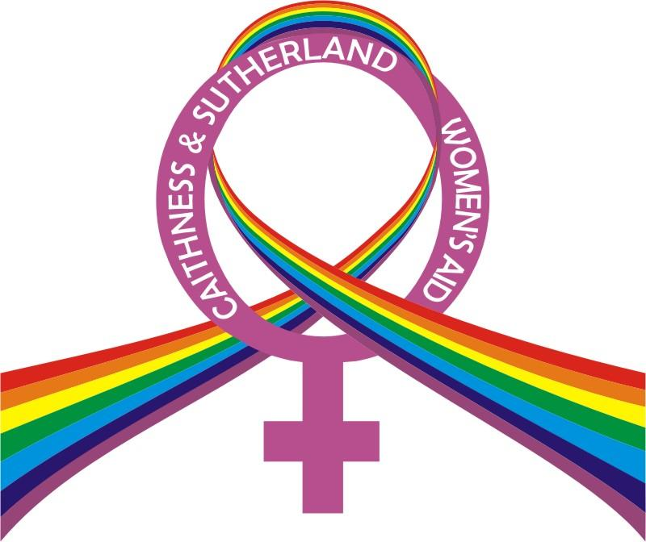
SELF REFERRAL APPLICATION FORM
OUTREACH SUPPORT
Please provide ALL relevant information when completing this referral form. Thank you.

NAME
PREFERRED NAME
DATE OF BIRTH
CURRENT ADDRESS

TYPE OF HOUSING
CONTACT TELEPHONE NUMBER
NATIONAL INSURANCE NUMBER
NUMBER OF CHILDREN-
GENDER AND AGE

WHAT FORMS OF ABUSE ARE YOU EXPERIENCING?

HAVE YOU HAD SUPPORT FROM WOMEN’S AID BEFORE?

DEPENDENCY ISSUES | DRUGS?  ALCOHOL?  PRESCRIBED MEDICATION?
HAVE YOU ANY CONCERNS OR ISSUES REGARDING YOUR CHILDREN?

HAVE YOU EVER CAUSED HARM TO YOUSELF, YOUR CHILDREN OR OTHERS?

PLEASE STATE IF YOU ARE RECEIVING SUPPORT FROM ANY OTHER AGENCIES.

PLEASE GIVE US ANY OTHER INFORMATION YOU FEEL MAY BE RELEVANT TO YOUR APPLICATION FOR SUPPORT.

CAN YOU TELL US WHERE YOU HEARD ABOUT OUR SERVICE?

I declare that the information I have given above is a full and honest account of my current circumstances.

Signature: Date:

Print Name:

Please send completed form via email to: info@caswa.org.uk
Or via post to:
CASWA, Naver Business Centre, Naver House, Naver Road, Thurso, Scotland, KW14 7QA

We will respond to referrals within 5 working days of receipt.

Tel: 0345 408 0151
Website: www.caswa.org.uk

